Name: Moteba Rehman

Date: June 16, 2026

Topic: Carbon Footprint of Generative AI

Task: Understanding CO2 Tracking tools

Supervisor: Ms. Zahida Kausar

Faculty Coordinator: Dr. Mewish Fatima

For this task, I installed and explored two carbon tracking tools:
- CodeCarbon
- CarbonTracker
I reviewed their documentation to understand their purpose, required inputs, outputs, and supported platforms.
Both tools are designed to estimate the energy consumption and carbon emissions generated by running software programs. They take information about the running workload and system resources and provide estimates of energy usage and CO₂ emissions.
To test the tools, I ran a simple Python loop and successfully generated carbon footprint measurements.
Both tools were installed and executed successfully. Screenshots showing installation verification and execution outputs are attached.
CodeCarbon Installation:
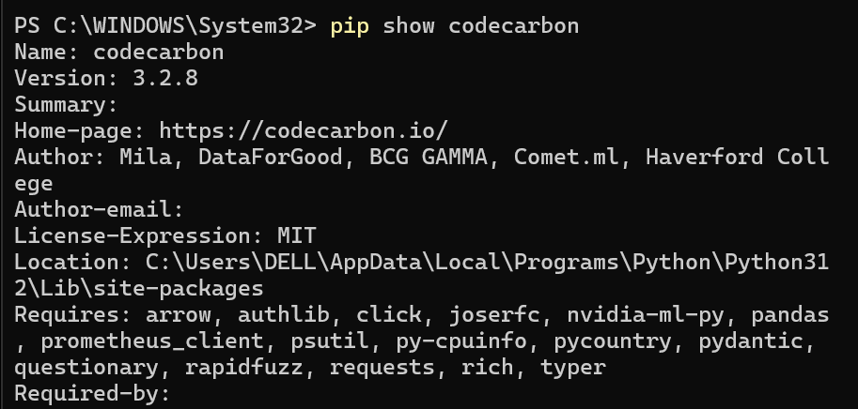
CarbonTracker Installation:
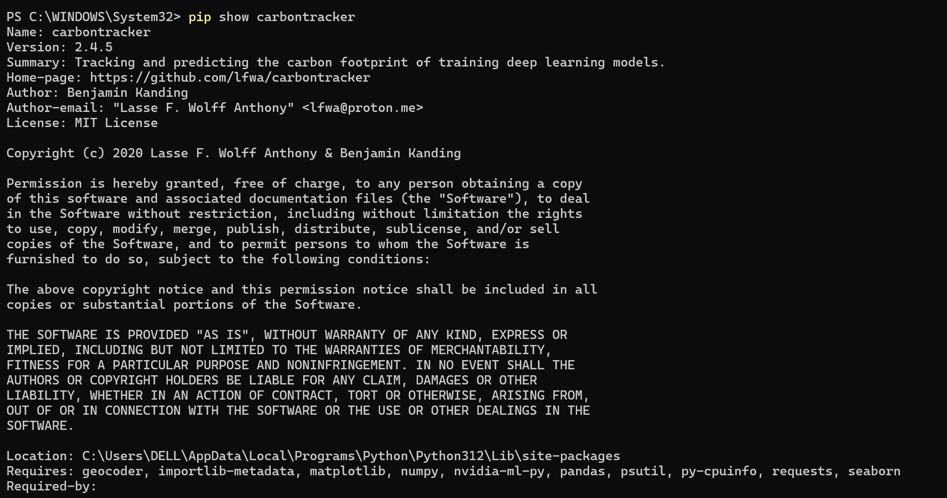
CodeCarbon Execution:
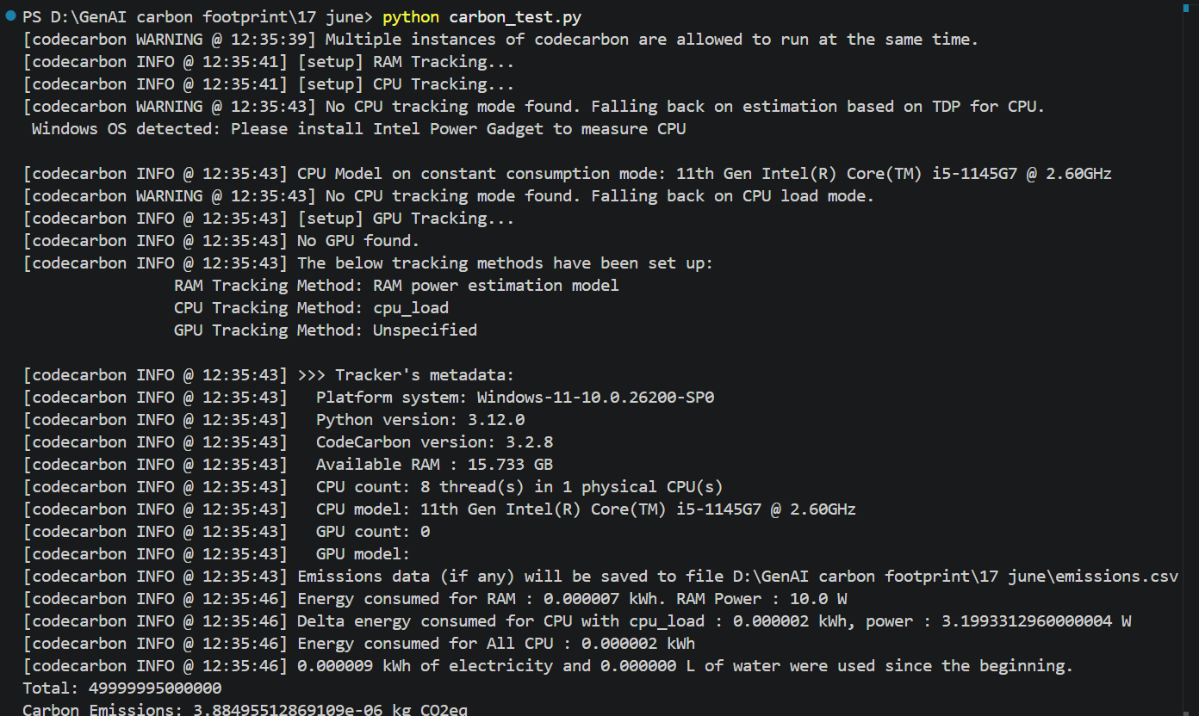
CarbonTracker Execution:
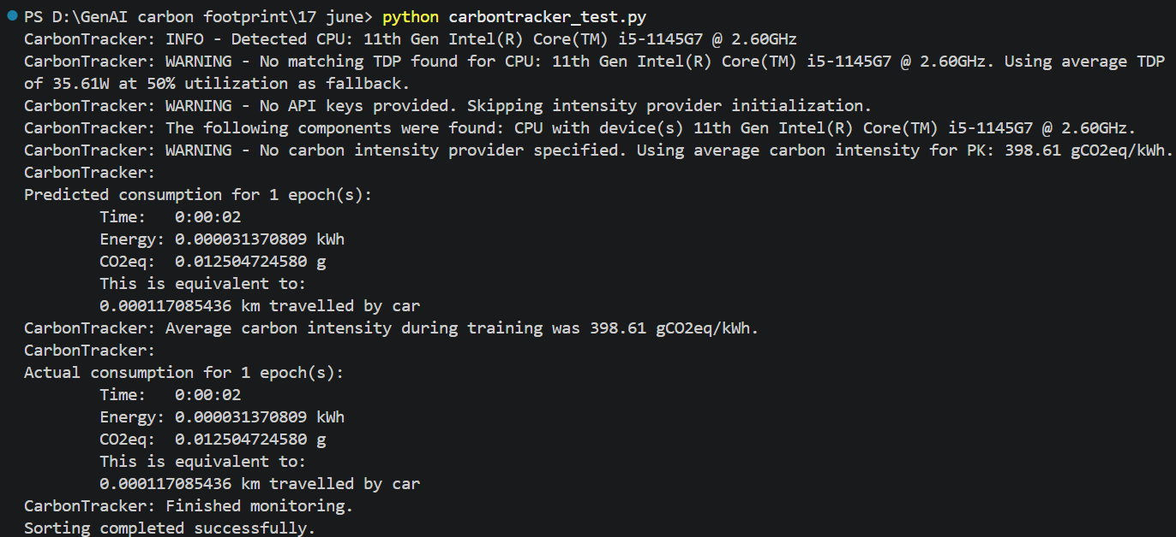
Emission.csv
